Ball Game

Project

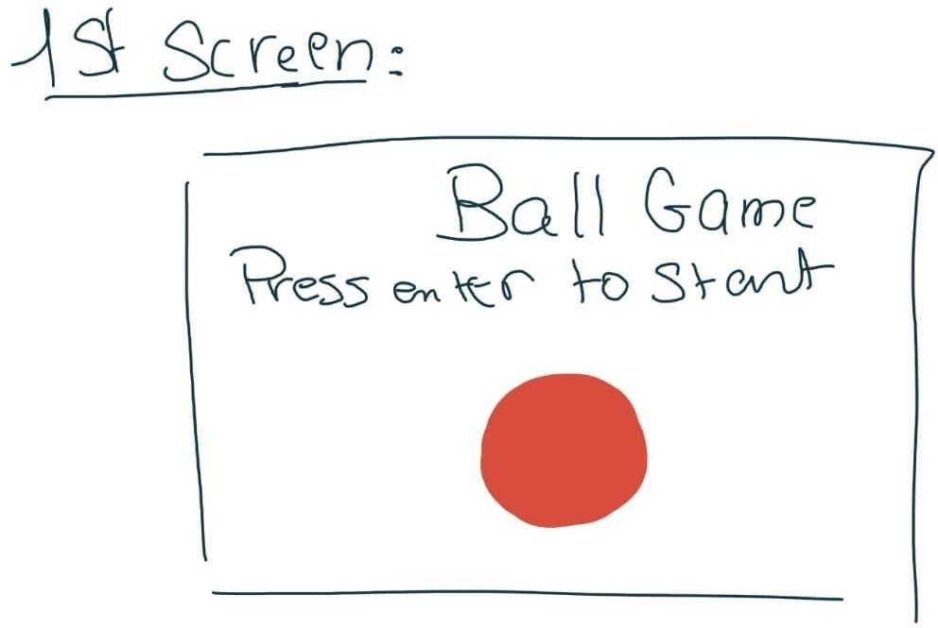

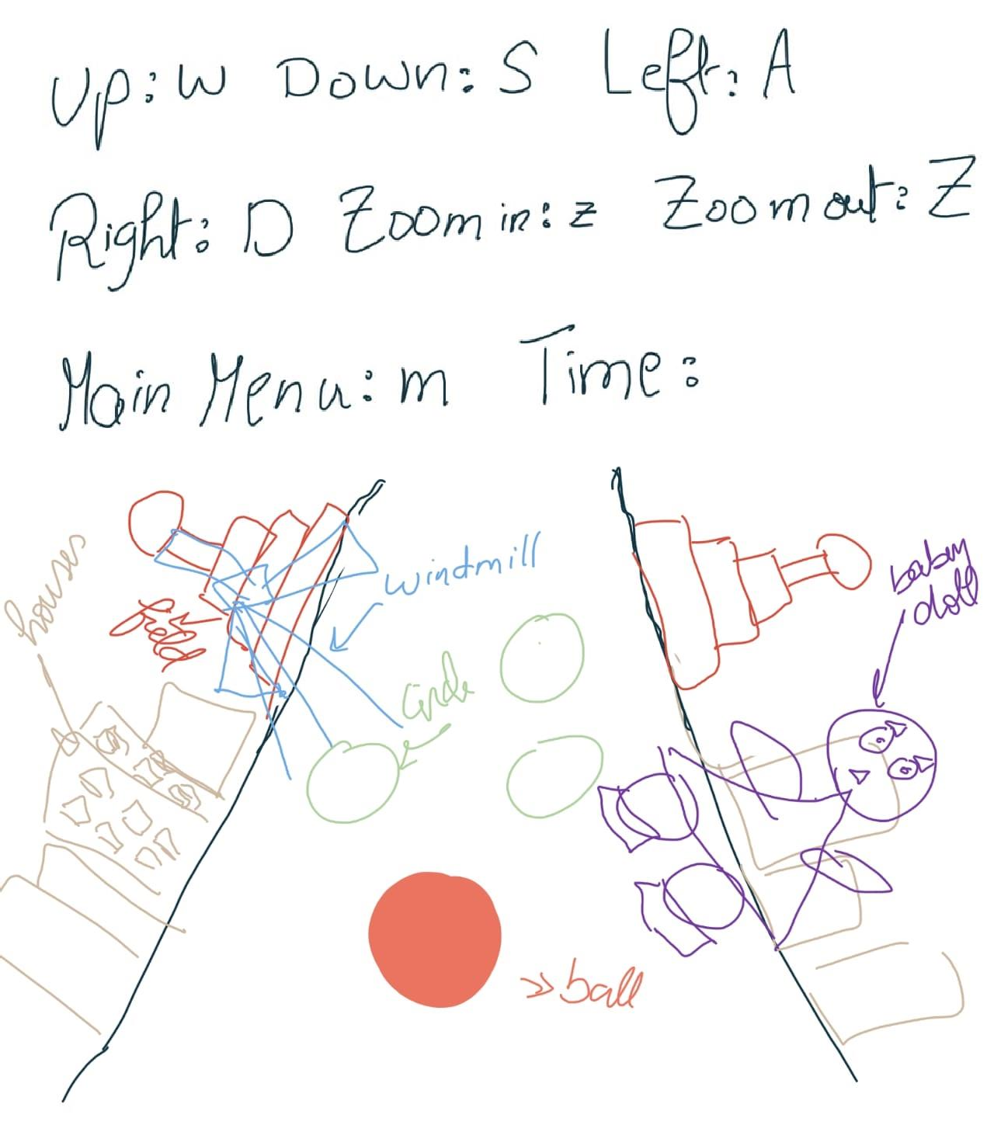

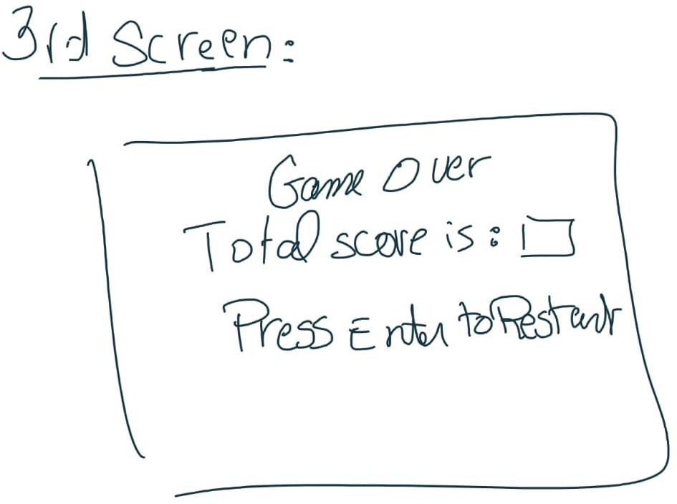

This our project imagination before we began. We thought about doing game similar to the idea of subway surfer but in our own imaginable way.

***The shapes we used:***

1. **CUBE**
2. **QUAD**
3. **CIRCLE**
4. **POLYGON**
5. **CONE**
6. **SPHERE**

***The animation we done on:***

* **THE BALL**
* **THE MOVING SCENE**

***Every work:***

1. designs and scene model
   * Ground
   * Field
   * Houses
   * Windmill
   * Baby doll
2. function implementations
   * Ball
   * Sound
   * Score
   * Animation
   * keyboard
   * Time

***Output appealing:***

